Task 7
Light in Bioart
Describe the influence of light on your body and well-being.
Describe the influence of light on the growth of moss and plants in the city. Document this with a few photos from their environment.
(Together 3/4 page text + approx. 5 photos)

The influence of light on our body
Light is a factor that awakens us to start the day. Some mornings we are very likely not to wake up when we don't see the light. Light is a force that initiates the day and energizes us. So much so that we become more pessimistic and withdrawn on days when the weather is cloudy. However, in sunny and beautiful weather, we are filled with happiness and energy. This is why light has a directly proportional interaction with our body as well as with our mood. Light energizes people. It is the strength that keeps it up. Light plays an important role in our focus of attention. Our eye guides us in terms of perception and movement. To give an example from my own body, dim and low-voltage lights create a feeling of tiredness and sleep in me. In the same way, it is the same with the weather: daylight plays a very important role in the motivation of both the body and the mind. If we look in the context of technology, blue light, especially in phones and computers, is very tiring for our eyes, causing some sleep and vision disorders.
As a result, light is a very important source of energy for both our physical and mental health in all areas of our lives, it brings vitality to people. A life without light always collapses the human body and slows it down.
The influence of light on the growth of moss and plants
The light, intensity and duration of the plant has a great effect on the structure and work of the plant organs. When the same plant species or variety are grown separately in abundant and low light environments, many changes occur in their morphological and physiological structures.
Environmental Factors Affecting Plant Growth Light
Light reaching the surface of a plant is either absorbed, reflected, or transmitted. Energy, in the form of sunlight is one of the driving forces in the chemical reaction known as photosynthesis. Photosynthesis is the process by which green plants manufacture food, mainly sugars, from carbon dioxide and water in the presence of chlorophyll (a green pigment), utilizing light energy and releasing oxygen and water. Together the quality, quantity, and duration of light influences plant growth. Plants grown in direct sunlight are typically compact, where as those in shade are taller and elongated. Seeds may start to grow (germinate) without light, but the plant growing from it must have light if it is to continue to grow.
How plants grow ?
Light: All living things, except for a few groups of bacteria, depend on photosynthesis for their existence. Photosynthesis is the process by which green plants make their own food. In the presence of light energy, plants manufacture food (mainly sugars), by combining carbon dioxide and water in the presence of chlorophyll to release oxygen and water.
Some examples from Weimar and Istanbul
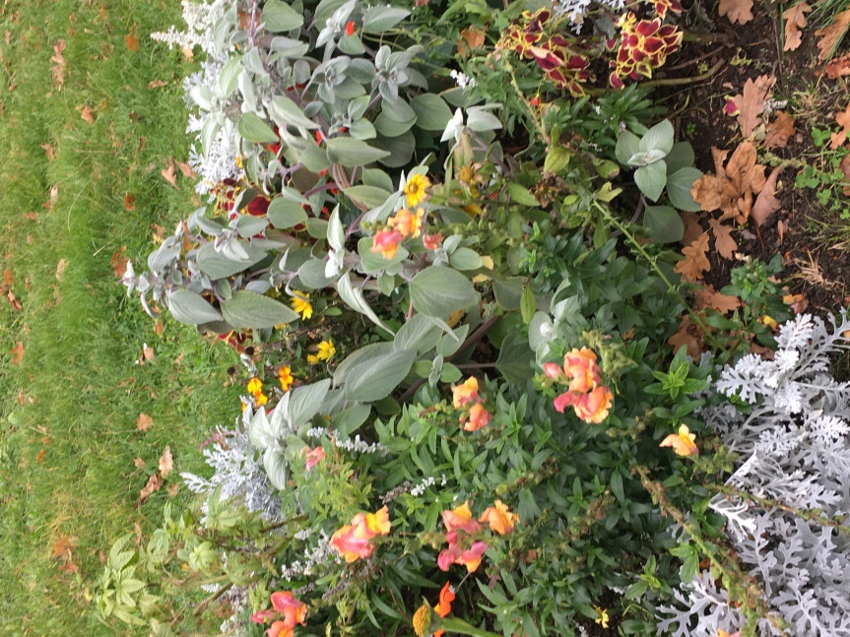

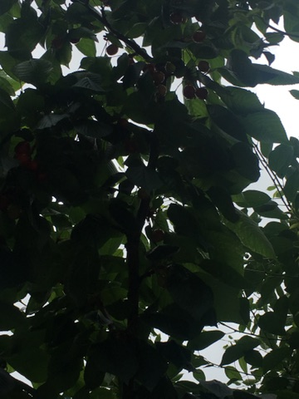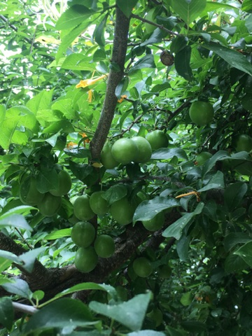
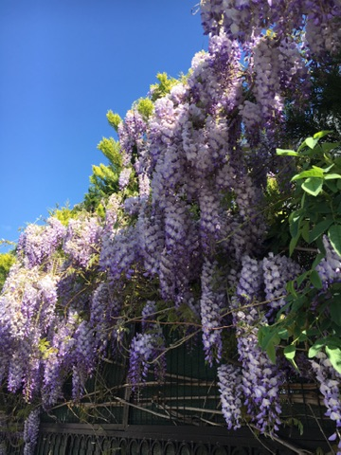
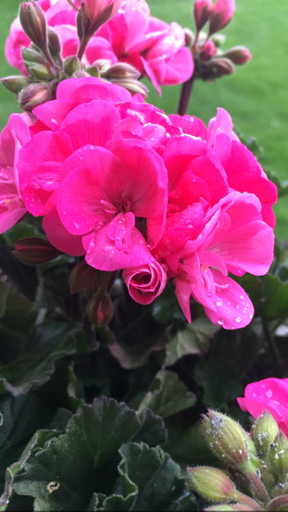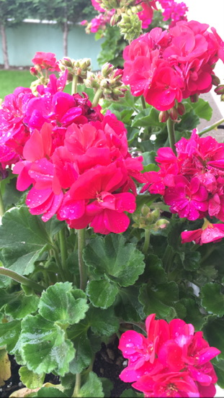

Helin Özdemir
122519
Dipl.Freie Kunst
Faculty of Art & Design

