Task 6
Rethinking the Urban
Please invent an action that is as provocative and radical as flooded mac donald's from superflex. Write it down and make a drawing / illustration / photomontage.

Theory I
Starbucks in Flood????

While McDonalds is similar to the event, I think the same effect could be for Starbucks, the world's largest coffee shop chain. For example, if Starbucks is left in water after a sudden pressure from the outside, it can cause a great disaster for itself. Flooding of all coffees, coffee counters and cans will create an extra and memorable effect under usual everyday conditions. Starbucks could have faced the biggest defeat and loss it has never experienced.
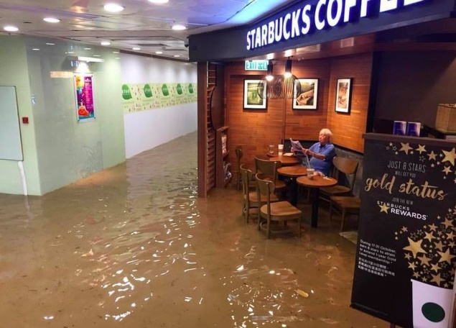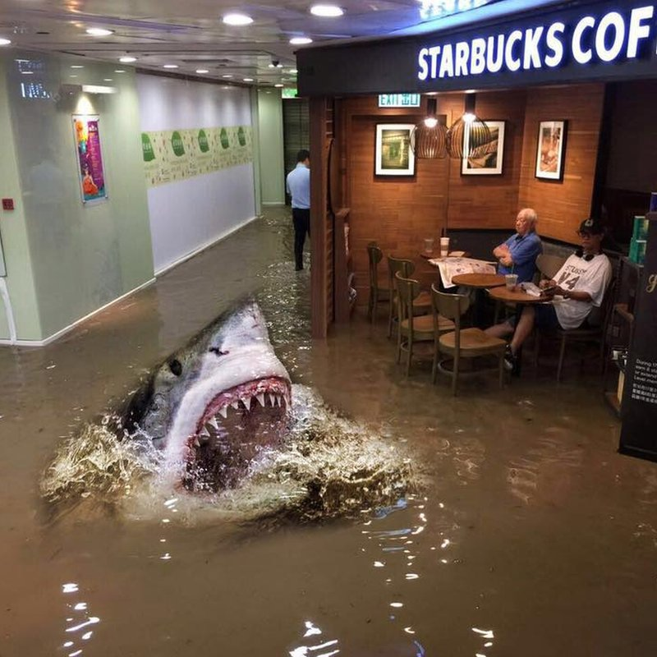
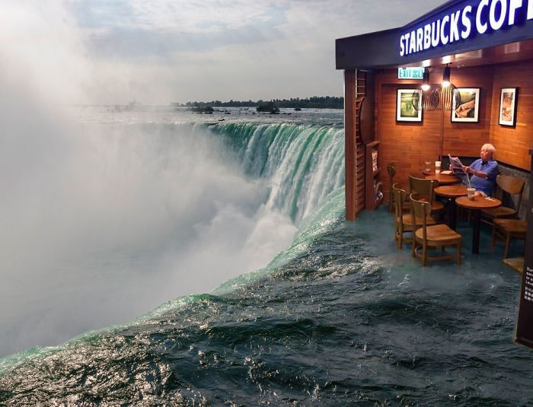

Theory II
Bombing to Starbucks ????

The bombing of starbucks by outer forces ...

The biggest bombing at the end of the biggest ventures at Starbucks. This event, which took place at the most unexpected moment, raises the question of whether a new age has come. The loud explosion of the bomb causes great panic in the environment. The chain of disasters that will occur as a result of this action, organized with this awareness, will be constantly remembered as an action that will not be interrupted. Over the years, this initiative, which was deliberately planned for Starbucks, will make its name frequently in history. Regular customers of the coffee chain will remember this incident in their minds and enter through the door.

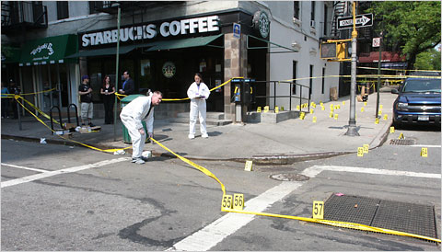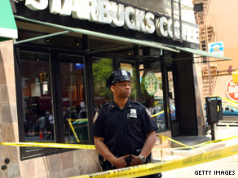
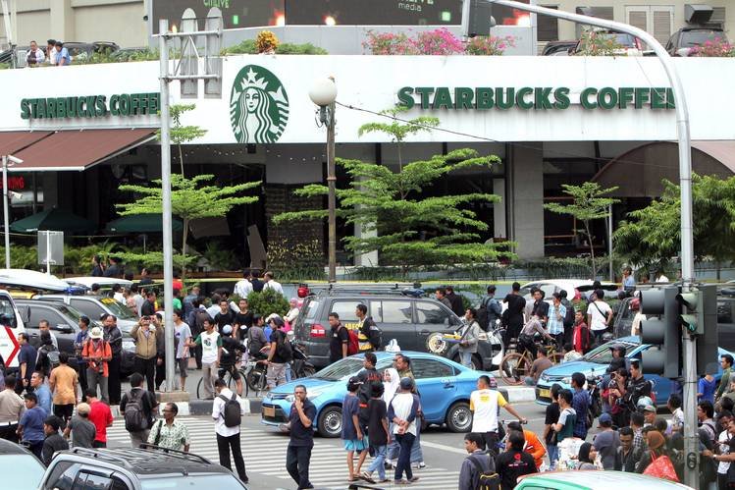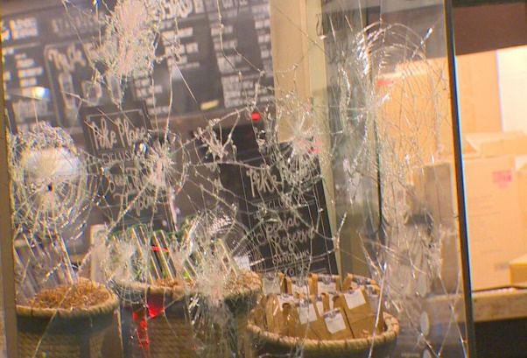

Helin Özdemir
122519
Dipl.Freie Kunst
Faculty of Art & Design

