Task 5
Performance Art

Choose one of the videos.
Make a re-enactment of it, as you can and like it.
Document it in 5 or more pictures or a short phone video.

Marina Abramovic
Relation Work 1979

Marina Abramoviç has been pushing the limits of her body with the possibilities of the mind in his 40-year career from the 70's to the present; She is one of the most courageous artists of the art history who literally lived in art and in my opinion.

Relation in Time described a static relation, the artist couple are sitting back to back, and their hair is firmly tied together, symbolising the bond between them. Each hour, a photograph was taken. There are few visible changes – sometimes Ulay sits with his eyes closed, sometimes Marina, or both have them open and look into the void. Their shared plait, their external connection, their umbilical cord, works loose as the hours pass. There is a contrast to the outward connectedness in their inward separateness, their different feelings. Again, as with the previous ones, this is an experience that the viewer can only follow visually, but cannot experience himself. Therefore Abramovic/Ulay's Performances live primarily on the intensity of their own experience and then in their visibility for the observer who, of course, may perceive both as role models. As in Relation in Movement, these Performances expose the principle of the individual as they progress, although they begin in a synchronised way, like two alarm clocks that were set at the same time, then gradually follow their own pattern.

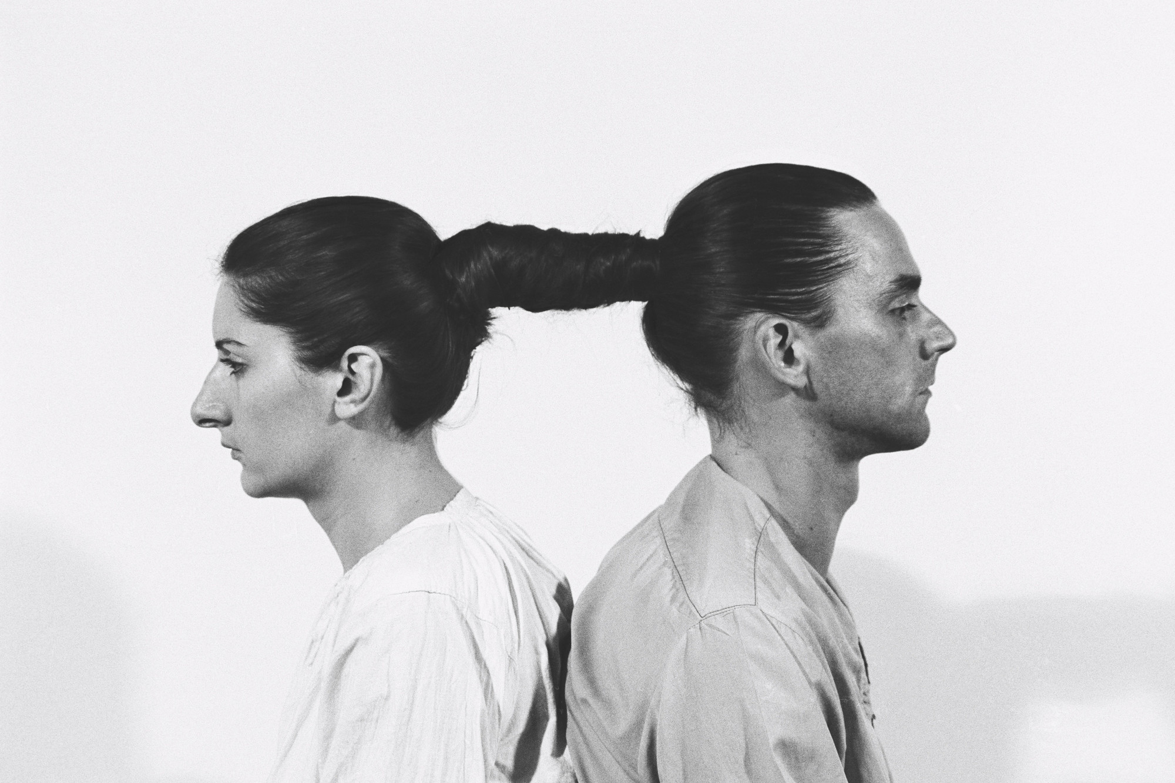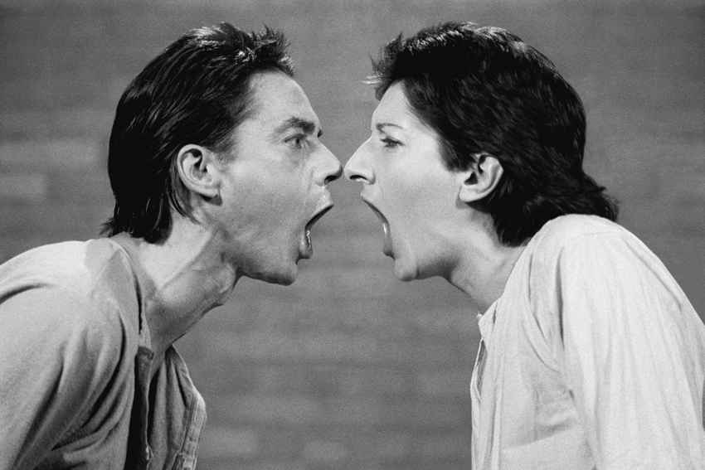

From my side new view to Relation Work today ..

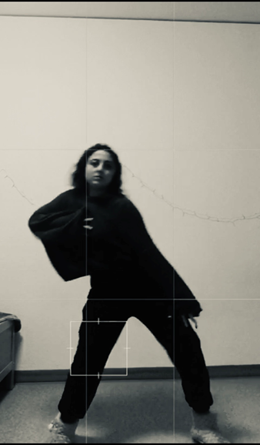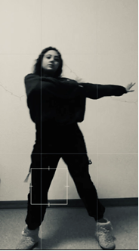

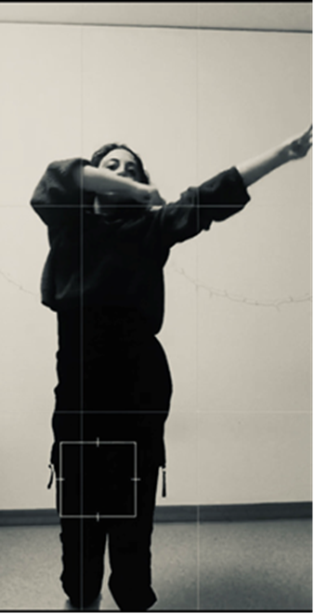
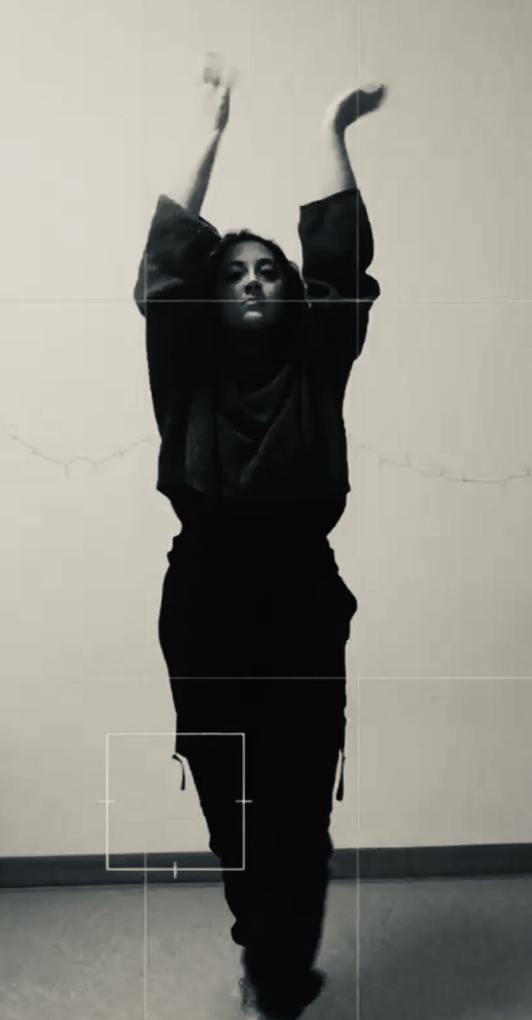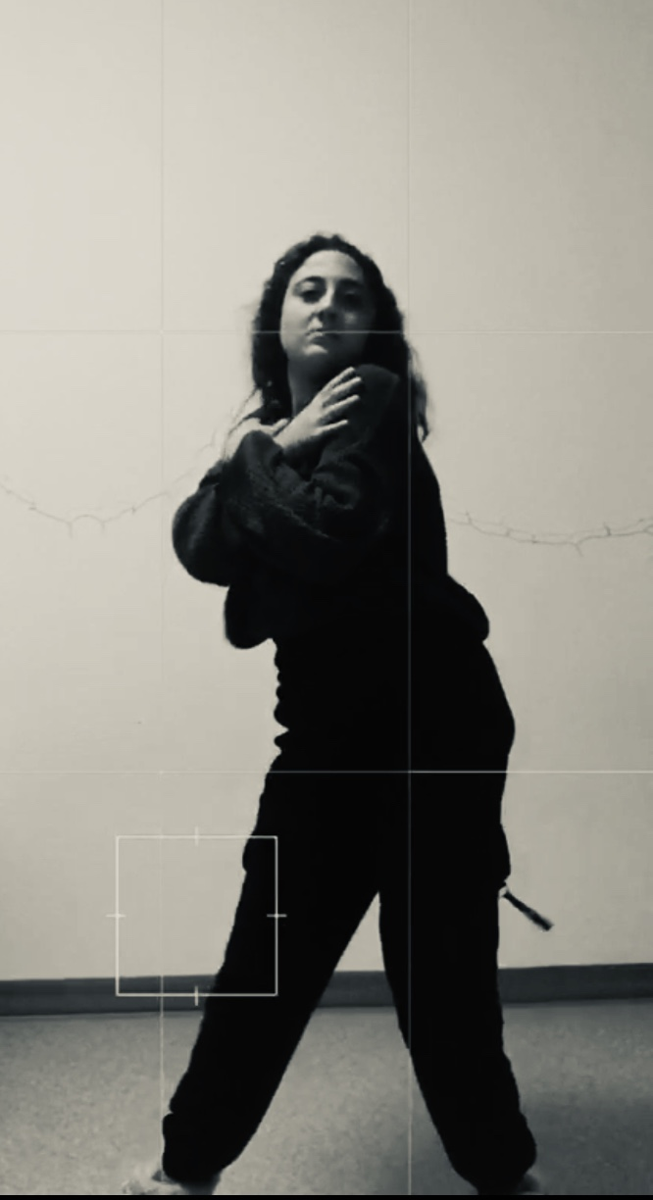

Helin Özdemir
122519
Dipl.Freie Kunst
Faculty of Art & Design

