Task 4
Maker Culture

- Describe the philosophical idea behind the Self-replicating machine.
There are many different points of view behind the machine that reproduces itself. One of them can be considered from a philosophical point of view, so that this issue of constant renewal and reproduction can be matched with the concept of mimesis. This issue, which is considered as the rival of nature, is like a new window opened by technology and reproducibility. According to Bowyer, philosophically this is associated with phenoemenology.
- Describe the advantages and disadvantages of Maker Culture.
Advantages
- Developing problem-solving skills
- Allowing creativity and innovation
- Encouraging collaboration and communication
- Promoting a growth mindset
- Learning new skills

Disadvantages

- It can become time consuming
- Some projects are dangerous
- It could cost you more
- Poor quality of work
- Significant Learning Curve

- Describe a DIY project that you like that is not present in the presentation.
Mason Jar Speakers
“The Audiojar by Sarah Pease is a Fun and Classy Do-It-Yourself Project”
The Audiojar by Sarah Pease is exactly what it sounds like. A sound system made out of classic mason jars, it is a fun do-it-yourself project that will add character to any computer or audio device set up. While the overall concept was creatively thought up by Pease, an industrial designer based in Jamestown, Rhode Island, the hardware was created by David A. Mellis.
Essentially, Mellis' Fab Speakers fit into the Audiojar by Sarah Pease. The speakers themselves are also a DIY project, the instructions of which can be downloaded straight from Mellis' website. The AudioJar is a beautifully basic encasement for the Fab Speakers, which is a great alternative to the laser-cut wood and fabric version he came up with himself.

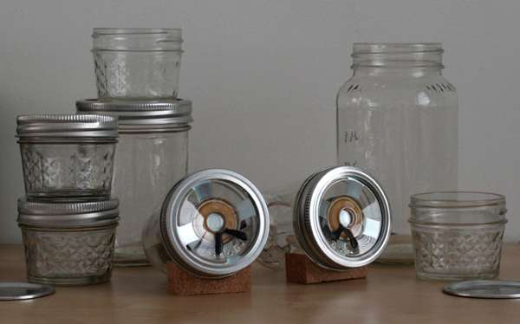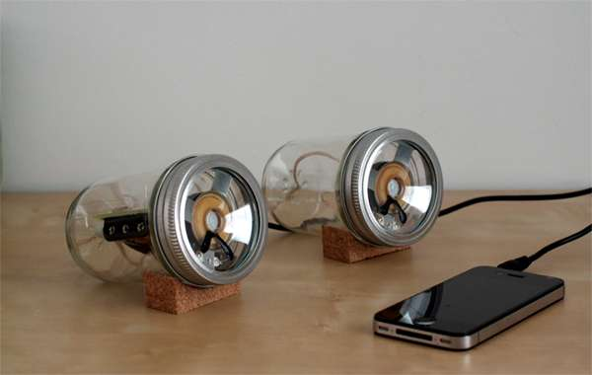

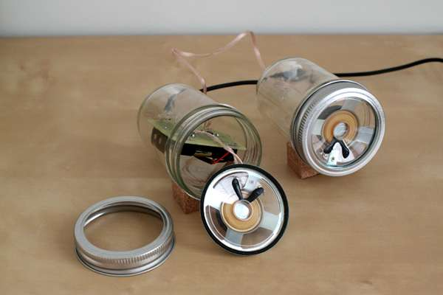

References
https://reprap.org/wiki/RepRap
https://www.trendhunter.com/trends/audiojar-by-sarah-pease

Helin Özdemir
122519
Dipl.Freie Kunst
Faculty of Art & Design

