TASK 3
Artificial Life and Beyond

- Describe an artificial, autonomous being or an autonomous machine from your everyday life and what it does. Describe your relationship to this being/artifact.
Robot vacuum cleaner
The types of vacuum cleaners that work without human interaction depending on a certain algorithm are called robot vacuum cleaners. There are also types of robot vacuum cleaners that sweep and pull solid and liquid materials on hard or soft surfaces into the chamber they contain, which automatically recharge themselves.
General features
Some features found in general of robot vacuum cleaners make these devices easy to use for home. These features can be listed as follows:
- Not falling from stairs and other elevations
- Detect collision, change direction after collision
- Carpet tassels, cables etc. not getting stuck on objects, getting rid of them in case of stuck
- Automatic charging by going to the base station / charging station
- Being imprisoned in rooms with virtual wall / magnetic strip-like apparatuses
- Real-time mapping by scanning with laser or infrared rays in some brands
- Self-cleaning and emptying the garbage container when returning to the charging station in both brands
This robot vacumm cleaner helps us to save our Daily life. For example , thanks to this model, which has been developed instead of consuming more power compared to conventional models, our workforce is reduced. The machines that we frequently use in our daily work in our daily life are small technology products that make our lives easier.

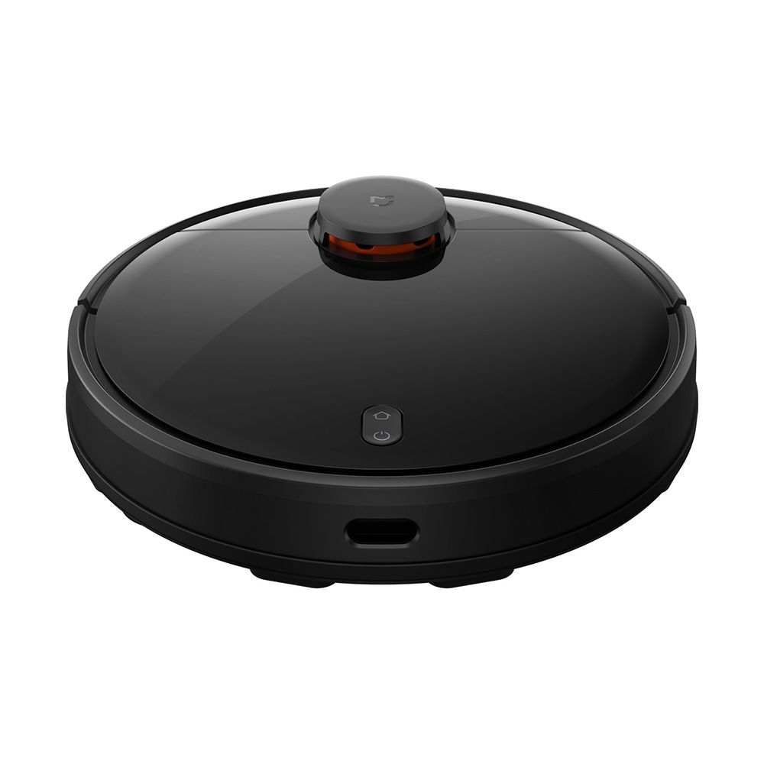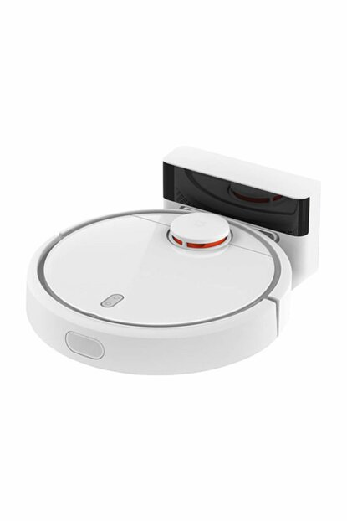
- Describe an artistic work from the lecture with your own words.
Ruairi Glynn
Performative Ecologies, 2012
In this artistic work uairy uses these light sticks as dancer and composes us as a whole performance of dances without any choreograped performance before in this installation .
Autonomous but very sociable performative robots search and orientate to face human inhabitants of their environment. When performing for their audience, they learn which of their performances are most successful, using facial recognition to assess attention levels. Using a Genetic algorithm they assess the 'fitness' of their performances disregarding less effective dances and try out more effective alternatives.
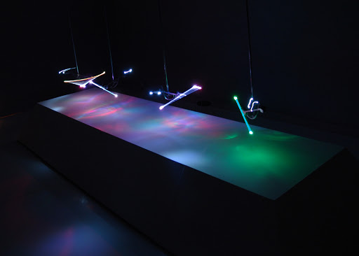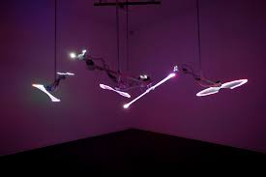
3) What would you be interested in if you were to build an autonomous artifact?
If I produced my own autonomous artifact, it would be a smart watch that works according to body temperature. Namely, it would be a system that would bring our body temperature to the ideal degree when we get cold or measure our body temperature by adjusting it to a lower degree when we get very hot. With this watch, which is a different production tool compared to the technology market, when we go out, we are allowed to move freely. Our daily clothes, which are constantly changing according to the weather, may not match at times. Thus, we can move freely and comfortably outside without being disappointed in the air temperature while carrying this smart watch.

REFERENCES
https://tr.wikipedia.org/wiki/Robot_s%C3%BCp%C3%BCrge
http://www.ruairiglynn.co.uk/portfolio/performative-ecologies/

Helin Özdemir
122519
Dipl.Freie Kunst
Faculty of Art & Design

