Self Organisation
•Describe a form of self-organisation from your everyday life.
If I need to describe the self-organization in my daily life, I can give an example of planning. I can only organize myself by planning. This is the most useful and correct method. I plan ahead for that day so that my day will not be empty and messy. Planning is of great importance in order to create an orderly environment. For example, typing, using calendar and creating reminders. All these combine to create an order in daily life. Just as composition is required for the integration of a part, the same applies to the person himself in daily life. A certain mechanism is formed as a mechanism when one force repels another and thus self-organization takes place.
•Develop a concept how you as a person can interact with this self-organization (half a page of text). Add three pictures that visualize the self-organization and the interaction.
Since the example I gave expresses an abstract concept, I developed another example of self-organization in this context. I achieved a rhythmic integrity by combining compositions based on a single piece, and I also provided the continuity of the sounds. The rhythm and senses that emerge as a result of the interaction of the parts continue continuously. As a result, since a single piece alone cannot produce a sound or something similar, I have created both visual and auditory integrity based on the multiplicity of the same parts. The sound of the pieces hitting each other continues continuously.
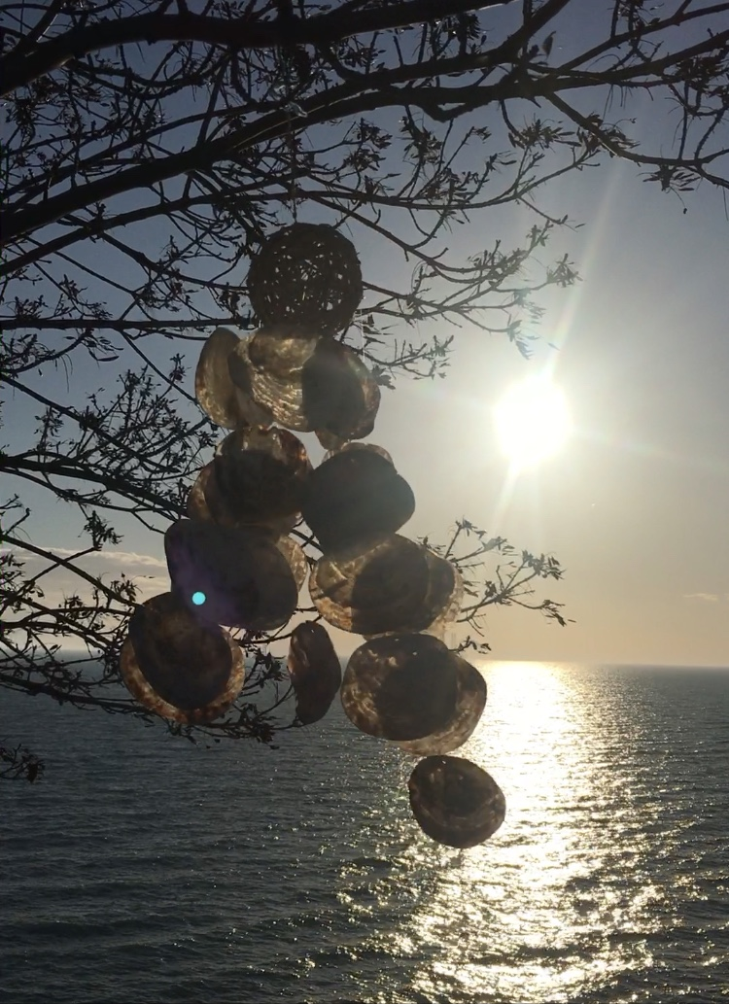
Helin Özdemir
122519
Media Art Strategies

