Task 1
Media Art Strategies

Please spend some time with the artworks included in the presentation.
Are they dealing with what you would consider media art strategies?
Which one you like most?
What is missing?
Please describe your impression on half a page.
Please create a page about a work of art according to the scheme of presentation with a work that seems to be missing in the present collection.

When I examine the works, they bear the traces of media art. With the changing age and technology, new branches of art have emerged. This art, which looks new even now in the age we live in, will develop more in the future and will undergo more changes than it is today. When media art is mentioned, I think of the act of performing an art in which technology is used extensively on digital platforms.

Art has sought a way of being for itself in many ways throughout history. It was a tool that was shaped around the artist's search for expression and transmitted the culture of the society he was in from generation to generation. Sometimes it progressed as a reaction to the variables, and sometimes it continued on its way by taking these variables with it. The artist, on the other hand, was nourished by the social, economic, political and technological situation of the period he was in, and at the same time, he had an identity that could direct the time he was in with his works and offered problems and solutions to change.

Artists have chosen a variety of expressions to express themselves throughout history. Movements such as expressionism, fauvism, futurism, surrealism, dadaism, and cubism all stemmed from the need for artists to express their common concerns using different methods and techniques in the way they express themselves.

Art in the 21st century is shaped around computer technologies. The artist now produces in a digital environment that has entered every aspect of our lives, expresses himself through software, and reveals his works with new media. Although new media is confused with video art, it is a completely different field that should be evaluated separately from it. Due to the materials and techniques used, it stands apart from the contemporary art framework as it is an interdisciplinary field of production. The diversity of the production process and structure has become almost limitless in line with today's possibilities and offers us new ideas and areas of inquiry.

From the lecture, “Random International: Rain Room “ is my favorite work. because it has a different perspective and understanding of media art. We don't see different digital screens or anything, but we can experience a different moment from real life. From this , we can understand that art can make anything doable. That's why people want to see what is inside that everyone wants to share this moment .

When it comes to artistic work, the Rain Room is a continuous rain shower that allows visitors to feel the moisture in the air and hear the sound of the rain without being affected by water droplets. Cameras placed around the room detect human movements and constantly send instructions to raindrops to steer clear of visitors. Before the water is sent back to the ceiling to fall again, it drips from a grid on the floor where it was treated.

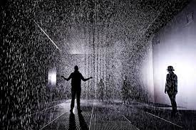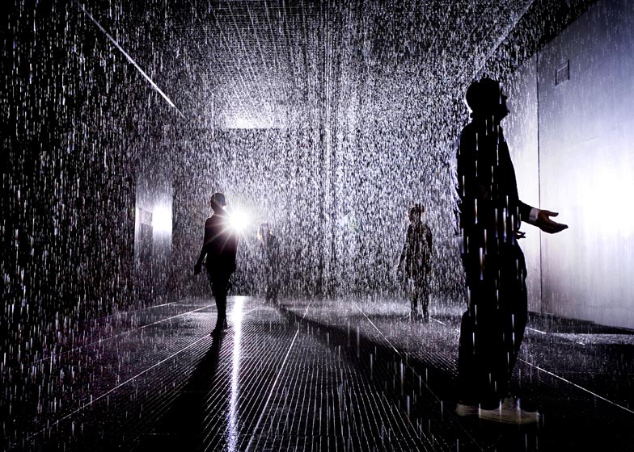

Helin Özdemir
122519
Dipl.Freie Kunst
Faculty of Art & Design

