IDEA FOR “SHARED HABITATS”

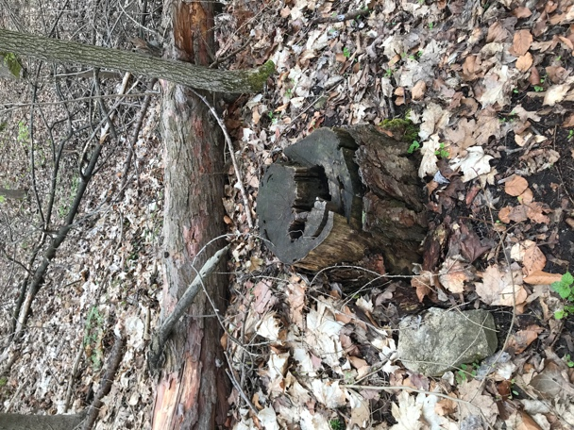 Take a set of photo about inside the wood and nature (forset). I was a few days ago in the forest and observed. I saw inside the trunk which has diverse fascinating creatures such as insects and ants. The structures of trunks' inside is like amazing architecture, I will use a flashlight to catch different shapes of trunks' inside.

In addition, I would combine, adjust, and change the images with some digital technic (change color saturation, do animation, documenting and filming them, create melodies matching with shapes of trunks)

Besides, taking some photos about the forest, which I would like to trigger imaginations of people. People can enjoy the photos as artwork, no matter what the images look like, people can see whatever they want in the photos.

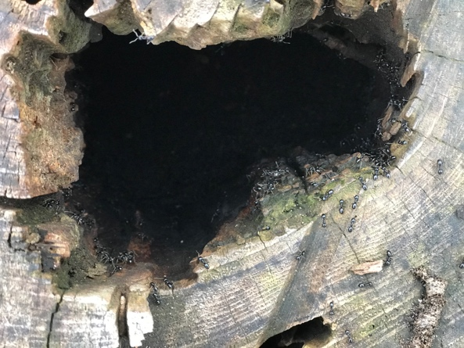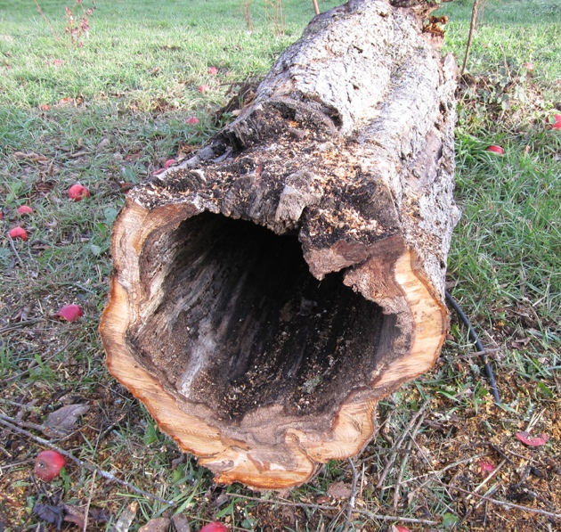

This project aims to show people (especially people my country) how amazing forest and nature creature brings to us. Nowadays in Vietnam in particular, there is increasingly less nature forest, people are more destroying nature. I want to show and raise awareness of people about the forest. As an artist, I found the forest is one of extraordinary spaces from which I can draw my inspiration or create art.

When I came here, I found the difference between my country and Weimar, people spend a lot of time enjoying nature, they playing, drawing, meeting in the part and walking through the forest instead of meeting in coffeeshops or mall center.

