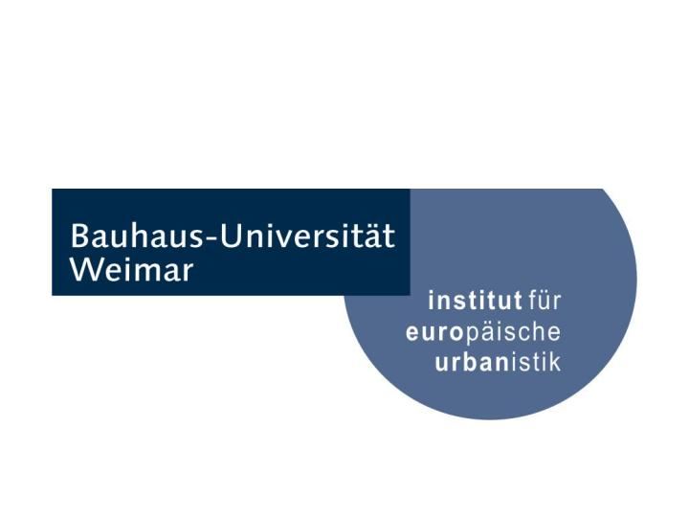
Doctoral Colloquium

Wednesday, January 17th, 2018
9:30 – 12:00
Belvedererallee 4, Room 101

Schedule
____________________________________________________________________________________________________________________________________________________________________________

9:30
Urbanism and Dictatorship: A Study on Urban Planning in Contemporary History of Iran (Second Pahlavi, 1941-1979)
Leila Javanmardi

10:15
Perception of Social-Spatial Segregation in Tehran Urban Area
Hanieh Shamskooshki

11:00
Cinematically dramatized cities: The case of east-German cities
Aisha Amman

12:00
Lunch

____________________________________________________________________________________________________________________________________________________________________________
Contact

If you have any questions, please contact: brigitte.zamzow@uni-weimar.de

